Software Requirements Specification Template

<Disease Prediction Using Machine Learning>

Software Requirements Specification
Python
<3.12.0>
< 2023-10-02>
Android Studio
<Android14>
<2023-1-1>

<Team Members>
Venkata Rami Reddy Yarram
Narasimha Raj Kumar Madasu
Venkata Mallikarjuna Rao Pola
Lohith Vamsi Bellamkonda
Arun Sai Ram Nuvvula

Submitted in partial fulfilment
Of the requirements of
CSIS 44-691 Graduate Directed Project 1

Revision History

Date | Description | Author | Comments
<date> | <Version 1> | <Your Name> | <First Revision>
Sept 8 | Data Collection | Lohith, Raj Kumar, Arun | Collected Datasets from Kaggle
Sept 18 | Data Pre-Processing | Raj Kumar, Venkata Yarram | Removed Null Values and cleaned data set
Oct 2 | Choosing Machine Learning Methods | Mallikarjun, Venkata Yarram | Chosen which machine learning algorithm is giving the accurate result
Oct 10 | Model Evaluation | Lohith, Raj Kumar, Venkata Yarram | Assessed the performance of the model using confusion matrix
Nov 3 | Model Comparison | Lohith, Arun | Used metrics like F1 score, AUC-ROC curve to compare the algorithms
Nov 3 | Interpretability | Raj Kumar, Venkata Yarram | Used Feature Importance graph to understand how it transforms input features into predictions
Nov 17 | Data Validation | Raj Kumar, Arun, Venkata Yarram | Checked the quality and accuracy of the input data used for training and testing machine learning models
Jan 29 | Login Page | Lohith | Created Login Page
Jan 29 | Sign Up page | Mallikarjun | Created Sign Up page
Jan 29 | User Profile page | Raj Kumar | Created User Profile page
Feb 5 | Home page | Raj Kumar, Arun | Created Home page
Jan24 | Android Code for Heart Disease | Venkata Yarram | Prepared code in the Android Studio to deployment
Feb 19 | UI for Brain Disease | Lohith, Mallikarjun | Created UI page for Brain Disease
Feb 19 | UI for Lung Disease | Raj Kumar, Venkata Yarram | Created UI page for Lung Disease
Feb 19 | UI for Skin Disease | Arun, Venkata Yarram | Created UI for Brain Disease
Feb 26 | Android code for Brain Disease | Lohith, Mallikarjun | Prepared code using Android studio for deployment
Feb 26 | Android code for Lung Disease | Raj Kumar, Venkata Yarram | Prepared code using Android studio for deployment
Mar 4 | Card view mode for login | Arun | Created card view mode of the login page
Mar 4 | Model Conversion for Brain Disease | Lohith, Mallikarjun | Converted model using TensorFlow Lite
Mar 4 | Model Conversion for Lung Disease | Raj Kumar, Arun | Converted model using TensorFlow Lite
Feb 26 | Android code for Skin Disease | Venkata Yarram | Prepared code using Android studio for deployment
Mar 4 | Model Conversion for Skin Disease | Venkata Yarram | Converted model using TensorFlow Lite
Nov 26 | Deployment | Lohith, Mallikarjun, Venkata Yarram | Done the deployment by merging the converted machine learning models along with android application
April 8 | Documentation | Raj Kumar, Arun | Prepared the documentation report

Document Approval

The following Software Requirements Specification has been accepted and approved by the following:
Signature | Printed Name | Title | Date
 | Dr. Ratan Lal | Professor

Table of Contents

Table of Contents Page Number

- Introduction
  - Purpose
  - Scope
  - Definitions, Acronyms, and Abbreviations
  - References
  - Overview
- General Description
  - Product Perspective
  - Product Functions
  - User Characteristics
  - General Constraints
  - Assumptions and Dependencies
- Specific Requirements
  - External Interface Requirements
    - User Interfaces
    - Hardware Interfaces
    - Software Interfaces
    - Communications Interface
  - Functional Requirements
  - Use Cases
  - Class/Objects
  - Non-Functional Requirements
3.5.1. Performance
3.5.2. Reliability
    - Availability
    - Security
    - Portability
  - Inverse Requirements
  - Design Constraints
  - Logical Database Requirements
  - Other Requirements
  - Prototypes (for complete project)
  - Use Case Diagrams
- Design
4.1. ER diagram
4.2. GUI
- Analysis Models
4.1. Data Flow Diagram
4.2. Sequence Diagram

1.Introduction
1.1 Purpose: Disease prediction using machine learning is a rapidly evolving field that leverages computational models to analyze medical data and make predictions about the likelihood of disease occurrence, progression, or outcomes. The integration of machine learning techniques in healthcare has the potential to revolutionize diagnostics, improve patient outcomes, and optimize resource allocation. The primary goal of disease prediction with machine learning is to develop models that can identify patterns, relationships, and trends within complex medical data. These models aim to predict the occurrence of diseases, assess the risk factors, and assist healthcare professionals in making informed decisions.

1.2 Scope: The scope of disease prediction using machine learning is broad and holds significant potential for transforming healthcare. Machine learning enables the development of models for early detection of diseases, such as cancer, diabetes, and cardiovascular conditions. Early identification allows for timely intervention and improved treatment outcomes. Machine learning facilitates the development of personalized treatment plans based on individual patient characteristics, genetic information, and responses to specific therapies.

1.3 Definitions, Acronyms, and Abbreviations:
ROC: Receiver Operating Characteristics
AUC: Area Under Curve
F1-Score: The F1 score is a metric commonly used in classification tasks, including disease prediction using machine learning. It is a measure of a model's accuracy that considers both precision and recall.

1.4 References: https://www.geeksforgeeks.org/disease-prediction-using-machine-learning

1.5 Overview:
Disease prediction using machine learning involves leveraging computational models and algorithms to analyze various types of data and make predictions about the likelihood of a person developing a particular medical condition. This field has gained significant attention in healthcare due to its potential to enhance early detection, risk assessment, and personalized medicine.
Electronic Health Records (EHRs): Patient data, including medical history, clinical notes, and laboratory results.

2. Product Description

2.1 Product Perspective
The project exists within the context of healthcare and aims to enhance disease prediction using machine learning. It aligns with the broader goal of improving patient outcomes through early diagnosis.

2.2 Product Functions
The primary functions include data collection, preprocessing, feature selection, model training, evaluation, and deployment. The project emphasizes the interpretability of models to foster trust among healthcare professionals.

2.3 User Characteristics
Users include healthcare professionals, data scientists, and system administrators. The system should be user-friendly for medical practitioners and technically robust for data scientists.

2.4 General Constraints
Constraints include ethical considerations, patient data privacy, and compliance with healthcare regulations such as HIPAA.

2.5 Assumptions and Dependencies
The project assumes the availability of diverse and relevant medical data for training robust models. Dependencies include access to suitable hardware and compliance with ethical guidelines.

3. 3. Specific Requirements
3.1 External Interface Requirements
3.1.1 User Interfaces
The user interface should be intuitive and user-friendly for healthcare professionals.
Include interactive visualizations to aid in understanding model predictions.
3.1.2 Hardware Interfaces
The system should be compatible with standard medical image acquisition and storage systems (PACS, DICOM).
3.1.3 Software Interfaces
Integration with popular machine learning frameworks (TensorFlow, Keras, PyTorch) is required.
3.1.4 Communications Interface
Ensure secure communication protocols for data transfer between the system and external components.
3.2 Functional Requirements
Implement data collection, cleaning, and preprocessing modules.
Develop feature selection algorithms to identify relevant attributes for disease prediction.
Select and implement machine learning algorithms for model training.
Incorporate model evaluation metrics, including accuracy, precision, recall, F1-score, and ROC-AUC.
Compare different machine learning methods to identify the most effective approach.
3.3 Use Cases
Define use cases for data collection, preprocessing, model training, and model evaluation.
Specify interactions between users and the system during these use cases.
3.4 Class/Objects
Identify and define classes and objects relevant to data representation, machine learning models, and user interactions.
3.5 Non-Functional Requirements
3.5.1 Performance
High Throughput: The system should be capable of handling a high volume of medical data efficiently, ensuring timely processing and predictions.
Scalability: Design the architecture to scale seamlessly, accommodating an increasing number of users and data points without compromising performance.
Response Time: Maintain low response times for user interactions to enhance the overall user experience.
3.5.2 Reliability
Prediction Accuracy: The system must demonstrate high accuracy in disease predictions, minimizing false positives and false negatives.
Error Handling: Implement robust error handling mechanisms to gracefully manage unforeseen errors and prevent system failures.
Data Integrity: Ensure the integrity of medical data throughout the entire processing pipeline to avoid data corruption.
3.5.3 Availability
24/7 Availability: The system should be always accessible to meet the unpredictable nature of healthcare demands.
Redundancy: Incorporate redundancy measures to mitigate the impact of potential hardware or software failures, ensuring continuous availability.
3.5.4 Security
Data Encryption: Employ strong encryption algorithms to secure sensitive patient data during storage and transmission.
Access Control: Implement strict access controls to restrict data access based on user roles, ensuring only authorized personnel can interact with the system.
Audit Trail: Maintain an audit trail of user activities and system changes for accountability and compliance purposes.
3.5.5 Portability
Cross-Platform Compatibility: Ensure the system is compatible with different operating systems and can run on various devices commonly used in healthcare settings.
Interoperability: Design the system to seamlessly integrate with existing healthcare IT infrastructure and standards, such as HL7 and FHIR.
3.6 Inverse Requirements
Boundary Conditions: Define specific boundary conditions under which the system should not make predictions. For example, if input data quality is below a certain threshold, the system may choose not to generate predictions.
Confidence Levels: Specify the minimum confidence levels required for the system to make predictions. This ensures that predictions are only provided when the model is reasonably certain.
3.7 Design Constraints
Ethical Guidelines: Clearly outline ethical considerations and constraints associated with the use of machine learning in healthcare. This includes considerations for bias mitigation, fairness, and transparency in decision-making.
Regulatory Compliance: Ensure that the design adheres to relevant healthcare regulations, such as HIPAA, to protect patient privacy and comply with legal requirements.
3.8 Logical Database Requirements
Schema Definition: Clearly define the database schema, including tables, fields, and relationships, to support the storage of diverse medical data.
Normalization: Apply normalization techniques to minimize data redundancy and improve database efficiency.
Data Retention Policies: Establish policies for data retention to comply with privacy regulations and ensure responsible data management.
3.9 Other Requirements
Usability Guidelines: Specify usability guidelines for the graphical user interface (GUI) to ensure it meets the needs of healthcare professionals. Consider factors such as readability, accessibility, and intuitiveness.
Documentation Standards: Define documentation standards for code, algorithms, and system architecture. Comprehensive documentation facilitates easier understanding, maintenance, and potential future enhancements.
Collaboration Protocols: Establish protocols for collaboration between data scientists, healthcare professionals, and system administrators to foster effective communication and knowledge exchange.
3.10 Prototypes (for complete project)
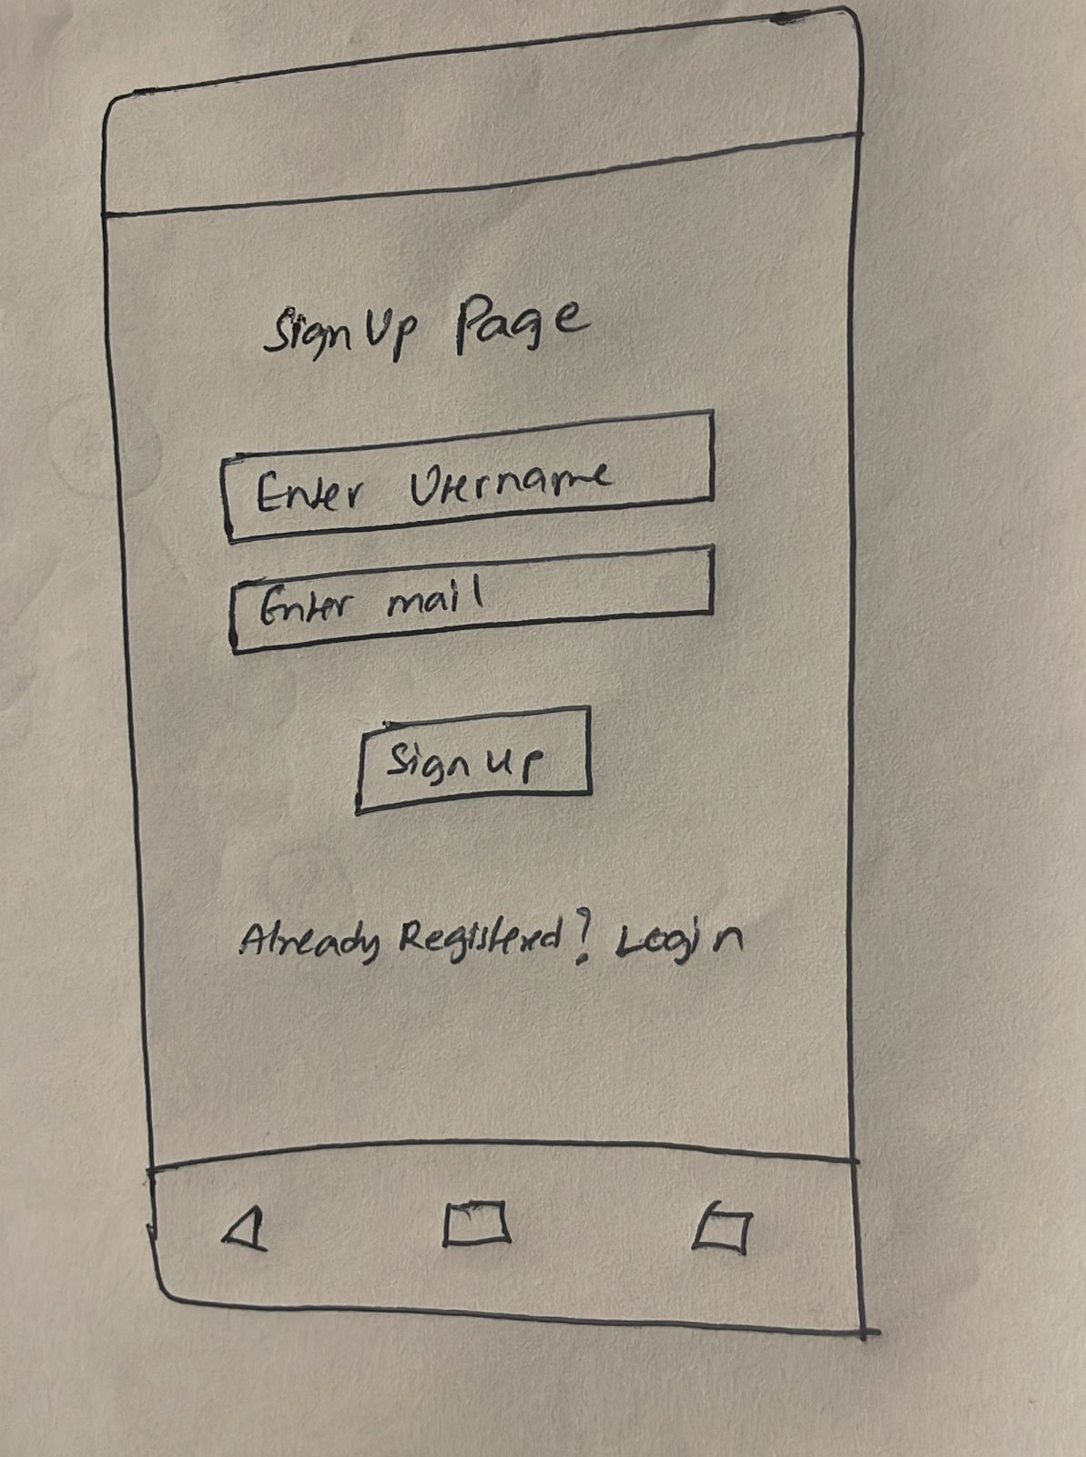
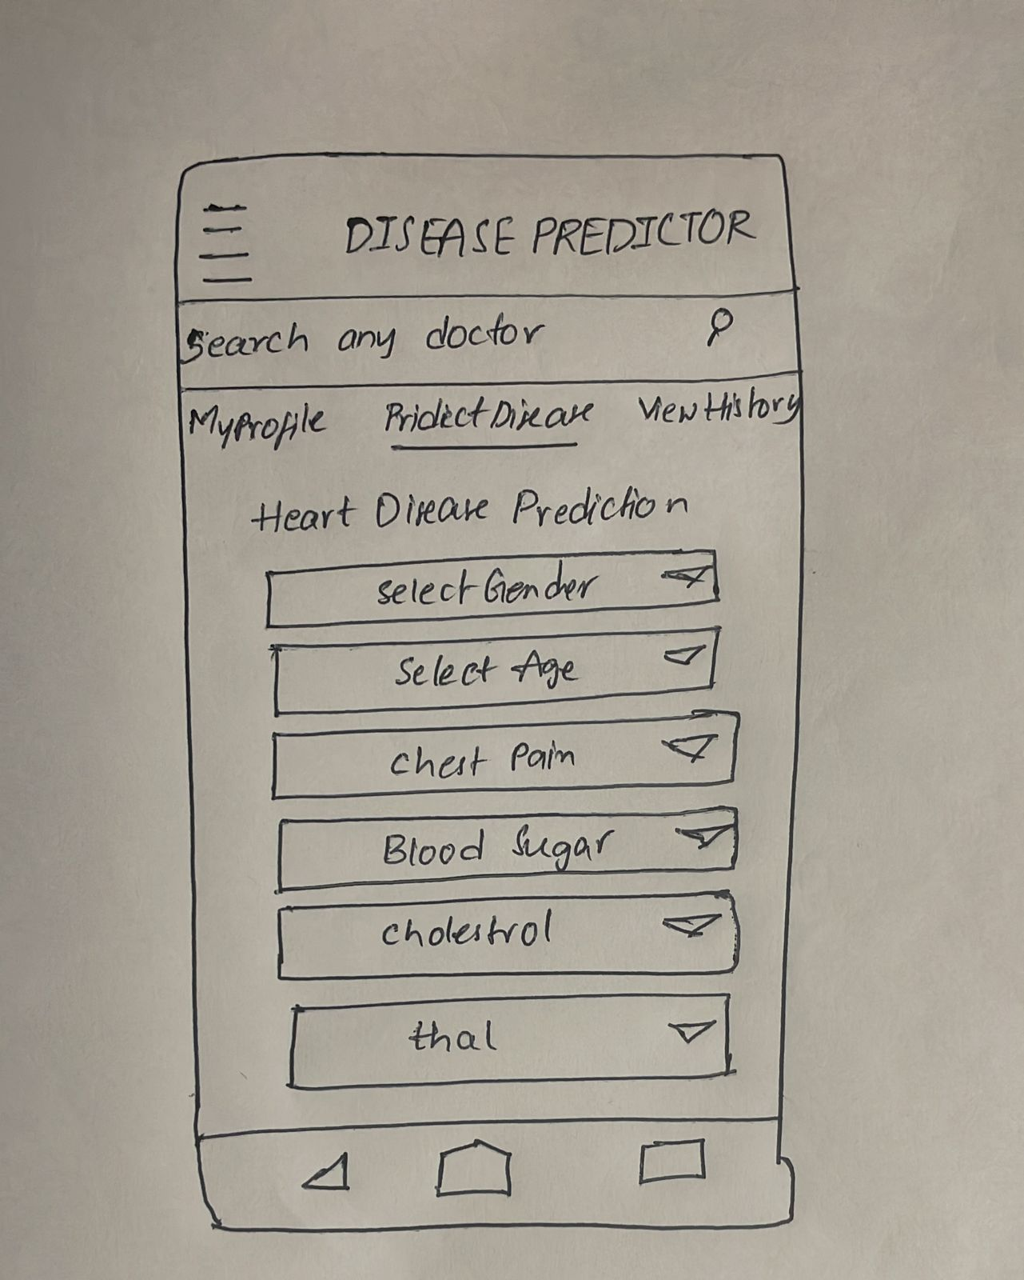
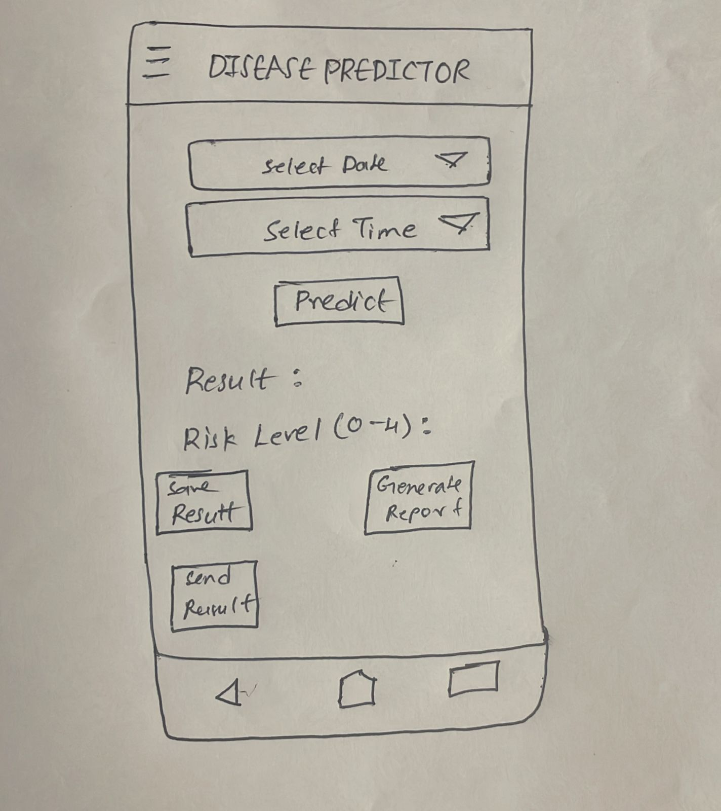
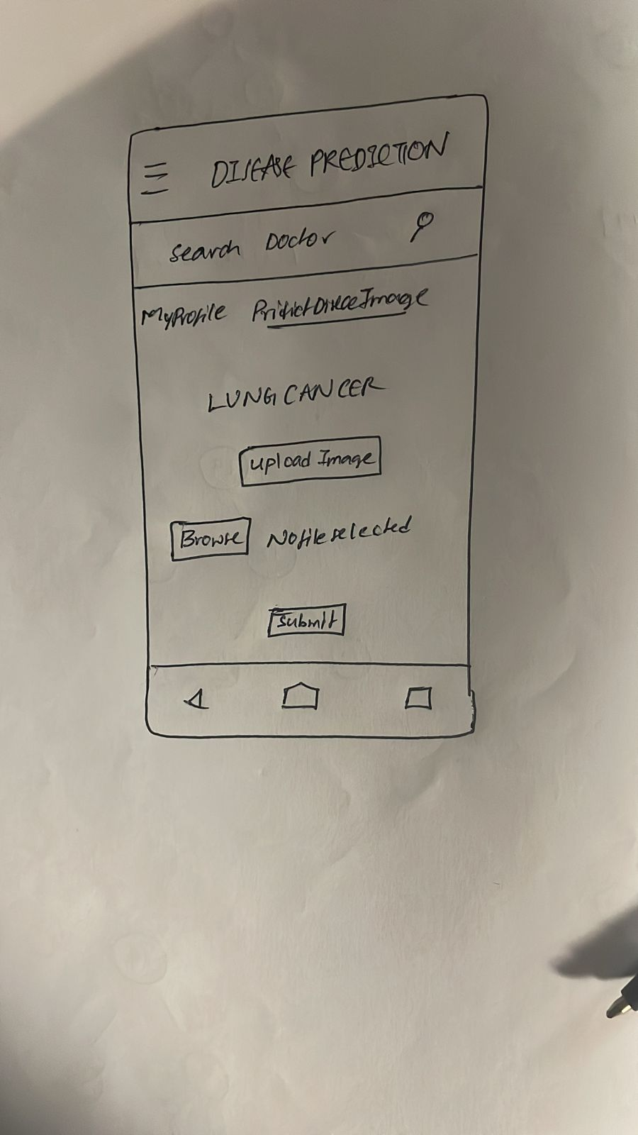
3.11 Use Case Diagrams
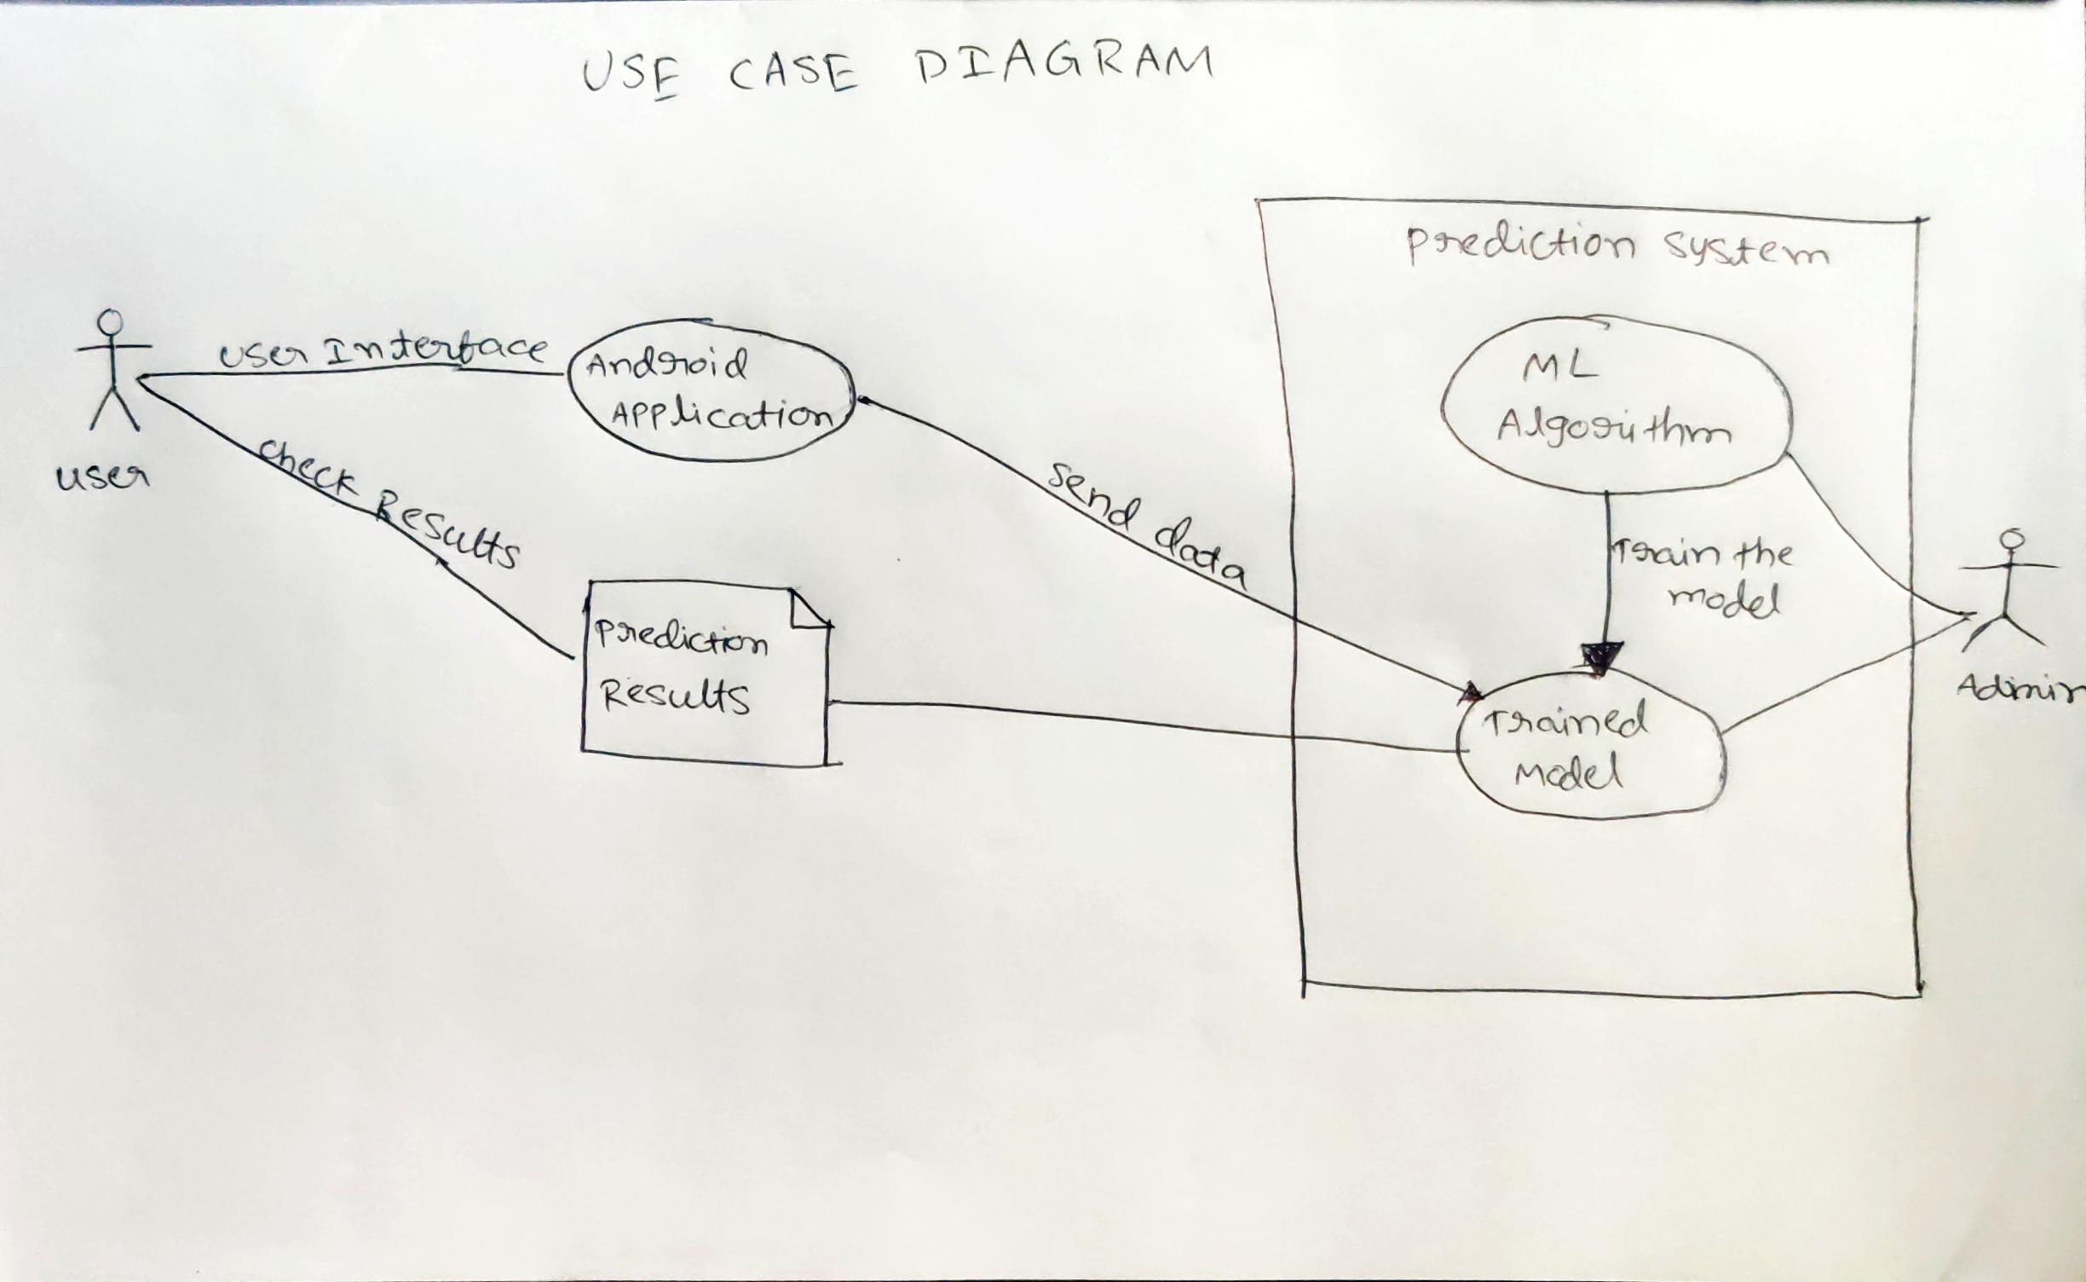

4. Design
4.1. ER diagram
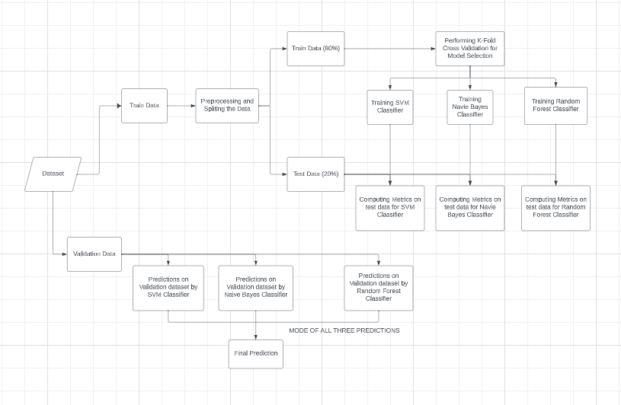

4.2. GUI
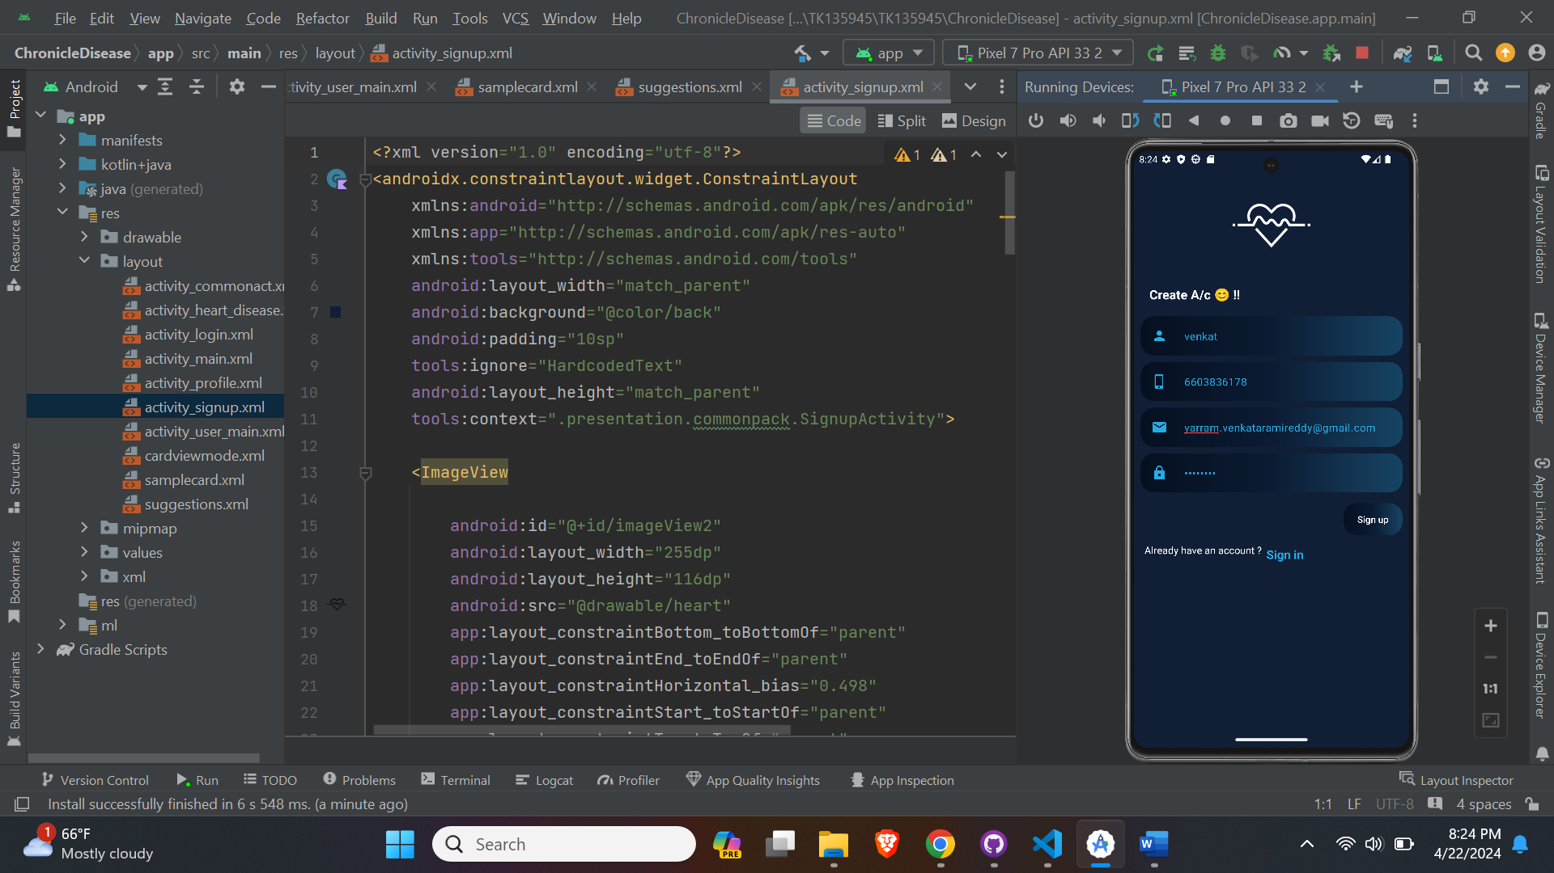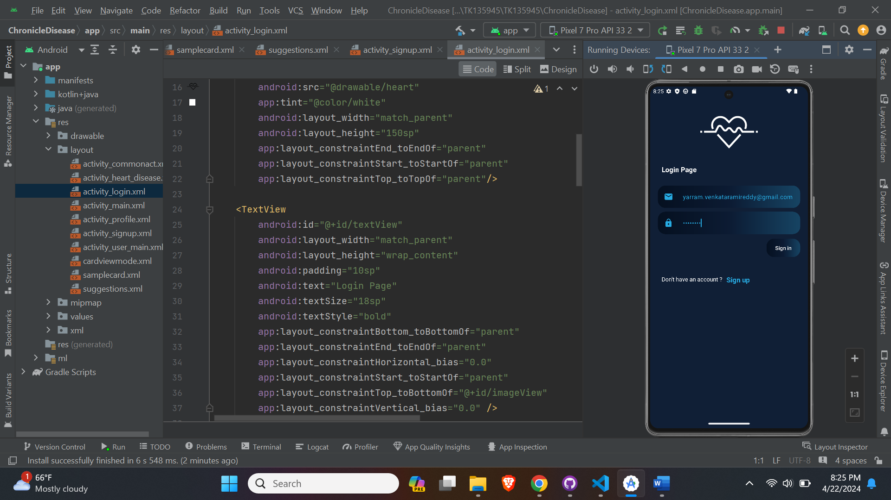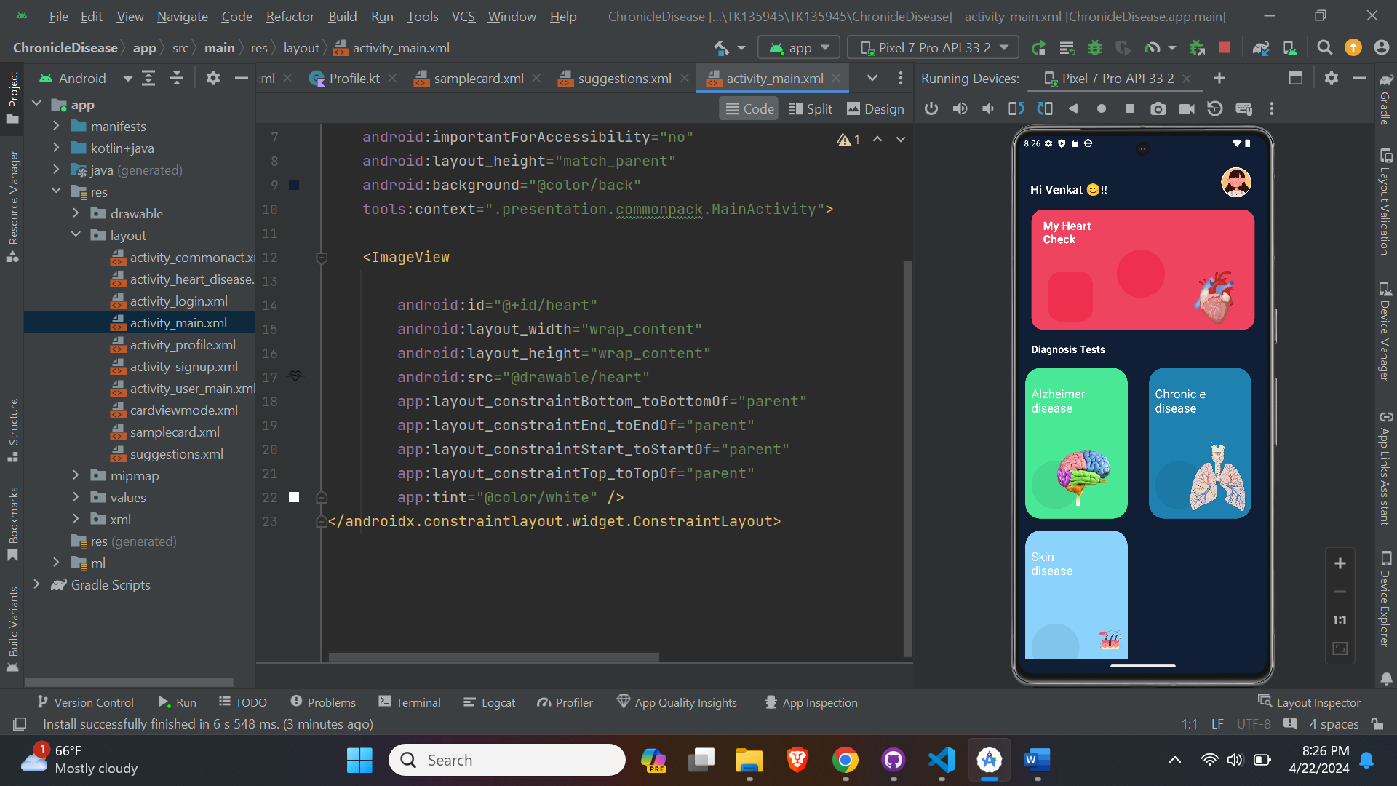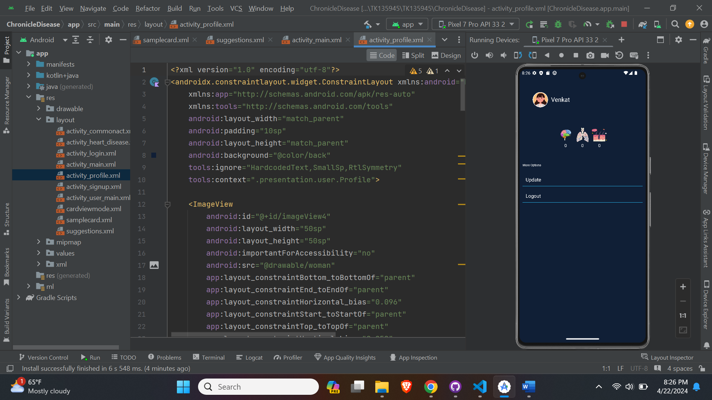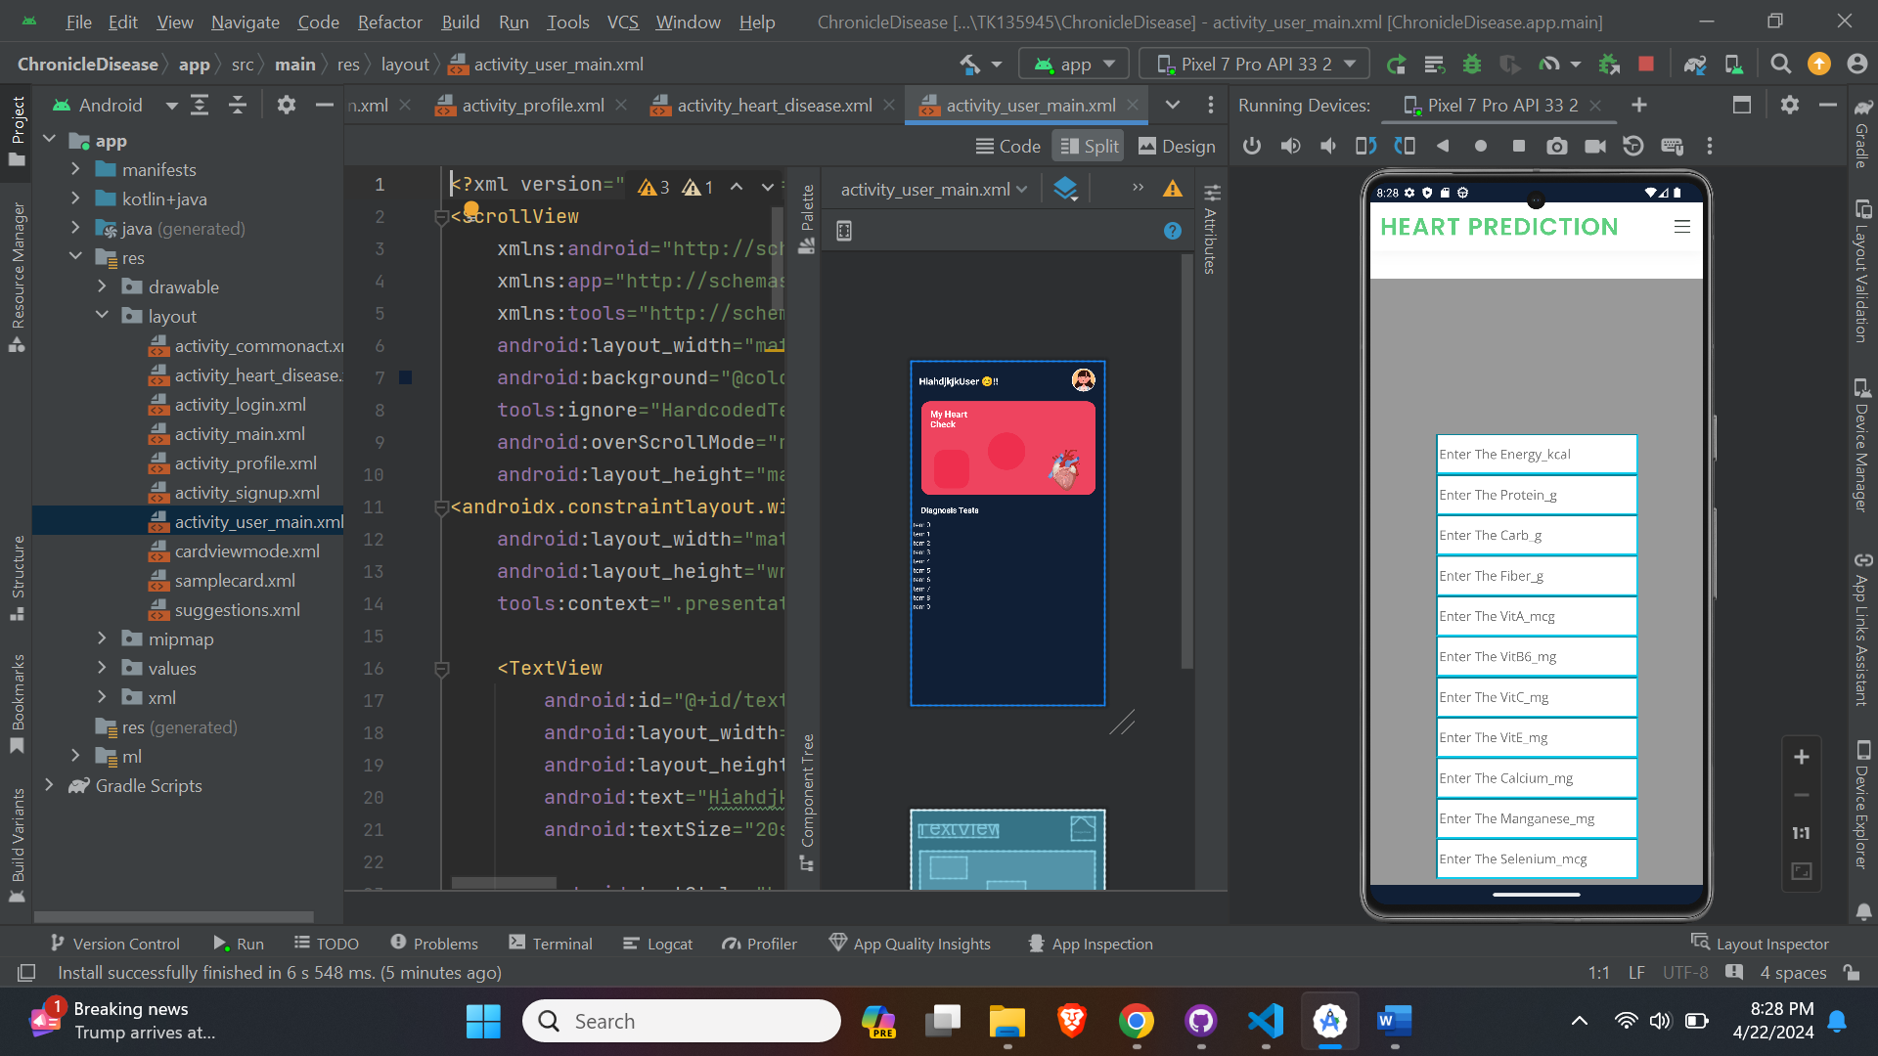
5.Analysis Models
5.1. Data Flow Diagram
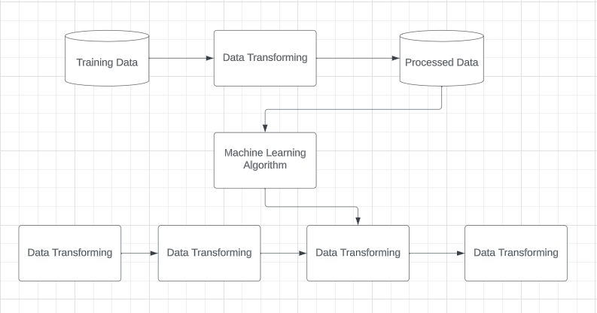

5.2. Sequence Diagram
